**USING RAPTOR –DISPLAY LENGTH OF STRING**

1. **V Bhargava(191911110)**
2. **FLOWCHART**

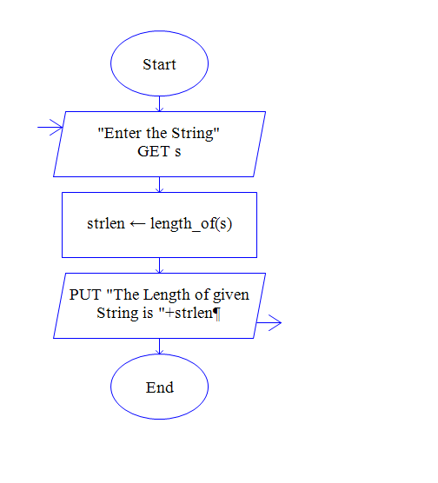

**INPUT**

**SAVEETHASCHOOLOF ENGINEERING**

**OUTPUT**

